Barak Barclay

Leslie Tekamp

ECE-1021

9 September 2015

1. 1.1 a) programs. b) Assembly language. c) High-level. d) machine language. e) compilers. f) open-source. g) UNIX.

1.2 a) editor. b) preprocessor. c) including other files in the file to be compiled, performing various text replacements. d) linker. e) loader.

1. 2.1 a) main. b) left brace ({), right brace (}). c) semicolon. d) printf. e) newline. f) scanf. g) %d. h) destructive. i) nondestructive. j) if.

3-8)

#include <stdio.h>

int main(void)

{

printf("I am learning the C programming language.\n\n""I am using Microsoft Visual Studio.\n\n""I will become a great C programmer.\n\n");

float y1 = 1.10 \* 100;

printf("y = 1.10 \* 100 = %f\n\n", y1);

int y2 = 3 / 5 + 51 / 3 \* 2 - 5;

printf("y = 3 / 5 + 51 / 3 \* 2 - 5 = %d\n\n", y2);

printf(" \*\*\*\*\*\n \* \*\n \* \*\n \* \*\n \*\*\*\*\*\n\n");

bool boolean = 1;

char character = 'A';

printf("%d, %c, %f, %d \n\n", boolean, character, y1, y2);

}

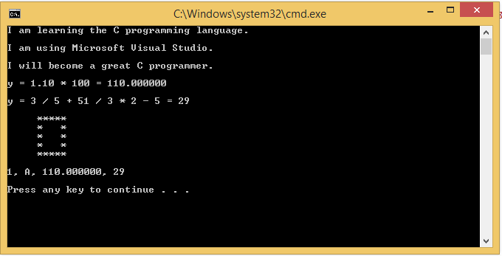

9)

Mathematian

Computer Scientist